**Power BI Assignment 2**

1. **Explain the advantages of Natural Queries in Power Bi with an example?**

## Ans: Introduction: Natural Language Query

## In the dashboard, there is a search bar that says **Ask a question about your data.**

## You can find insights that might not exist in your report but exist in your model based on the measures you’ve already created.

## The Natural Language Query is an advanced feature that can find almost any insight. It’s continually being improved and one day it will be implemented in other Microsoft Office apps such as Outlook or Teams.

## Natural Language Query

## Advantages of Natural Queries in Power Bi:

## With the Natural Language Query, you can query your reports and get answers.

## With the Natural Language Query, you can query your reports and get answers.

## It requires no prior knowledge on any querying language like SQL, excel. Querying, it is like common English.

## Simplifying employee access to BI data.

## Driving deeper business insights.

## Reducing confusion about analytics results.

## Applying structure to unstructured data

## Example: We can type in the search bar “****show total sales by customer name**”** and it will show the chart or report that corresponds to the search.

## Q&A Power BI

Fig: Example of Natural Language Query in power BI

1. **Explain Web Front End (WFE) cluster from Power BI Service Architecture?**

**Ans: Power BI Service Architecture:**

The Power BI service is built on **Azure**, which is Microsoft’s cloud computing infrastructure and platform.

When the reports are published on Power BI Service, clients can access them via their mobiles, tablets, desktops, etc.

**Power BI service architecture is based on two clusters –**

1. Power BI Web Front End Cluster (WFE)
2. Power BI Back End Cluster

**Power BI Web Front End Cluster (WFE)**

* The Web Front End Cluster plays the role of managing the initial connection between the back-end cluster and the end-user.
* It uses AAD (Azure Active Directory) to authenticate the client and ensure security.
* In addition to that, it offers several tokens for connecting clients to the Power BI Service.
* **Azure Traffic Manager** (ATM) used to direct user traffic to the nearest datacenter, determined by the DNS record of the client attempting to connect, for the authentication process and to download static content and files.
* Power BI uses the **Azure Content Delivery Network** (CDN) to efficiently distribute the necessary static content and files to users based on geographical location.

**Web Front End (WFE) cluster manages two important components.**

* Initial connection
* User Autentication

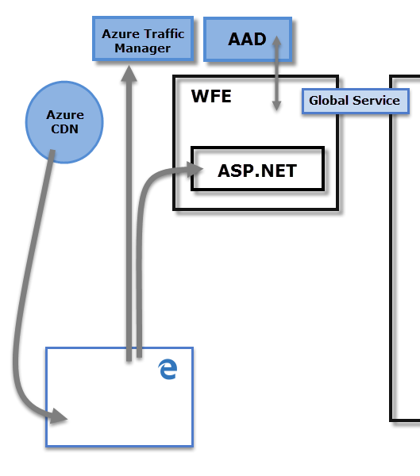

Fig: Power BI Web Front End Cluster (WFE) Architecture

1. **Explain Back End cluster from Power BI Service Architecture?**

**Ans: Back End cluster from Power BI Service Architecture manages:**

* Visualizations
* User dashboards
* Datasets
* Reports
* Data storage
* Data connections
* Data refresh and other aspects of interacting with the Power BI service.

At the back-end, a web client has only two direct points of interaction

* Azure API Management
* Gateway Role.
* The **Gateway Role** acts as a gateway between user requests and the Power BI service. Users do not interact directly with any roles other than the **Gateway Role**.
* **Azure API Management** will eventually handle the **Gateway Role**.

These two components are responsible for load balancing, authentication, authorization, routing, etc.

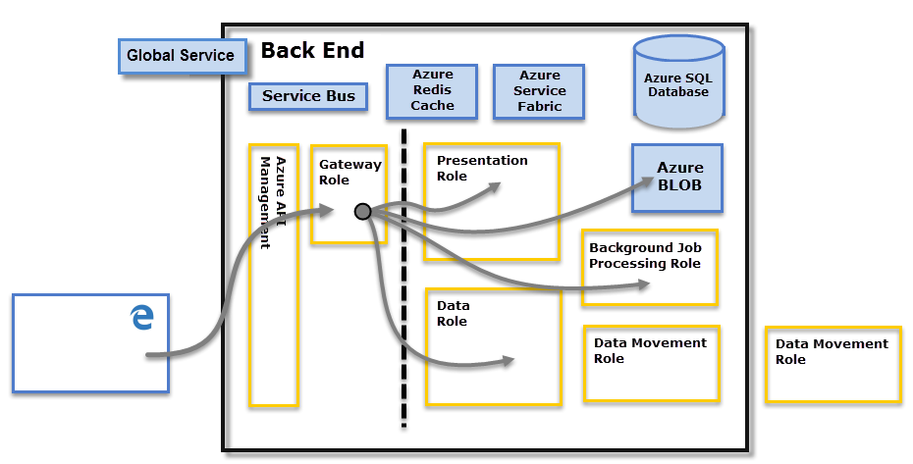

**Fig: Power BI Back End Cluster Architecture**

1. **What ASP.NET component does in Power BI Service Architecture?**

Ans: ASP.NET is a web development platform provided by Microsoft.

* ASP ==> Active Server Page
* NET ==> Network Enabled Technologies

ASP.NET component plays a major role while publishing reports and dashboards to workspace where stakeholder interact with it in front end provided by Power BI service.

Not only that, BI dashboards can also be accessed through other apps like Microsoft teams which embeds BI Applicaiton through ASP.NET framework

1. **Compare Microsoft Excel and Power Bi Desktop on the following features:**

**Data import**

**Data transformation**

**Modelling**

**Reporting**

**Server Deployment**

**Convert Models**

**Cost**

Ans: Comparison between Microsoft Excel and Power Bi Desktop: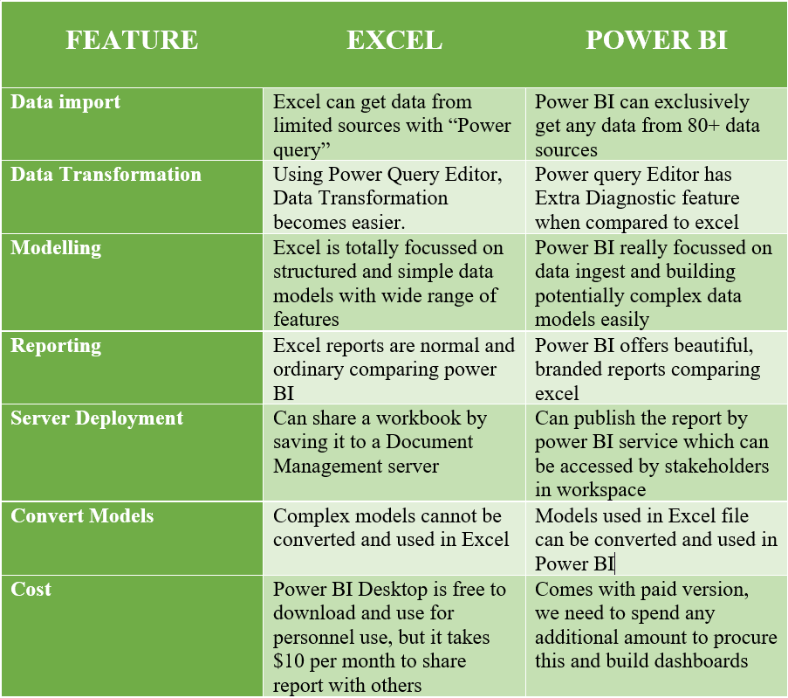

1. **List 20 data sources supported by Power Bi desktop.**

**Ans: Data sources supported by Power Bi desktop:**

1. Access database
2. Oracle Database
3. Parquet
4. Mysql Database
5. Postgre Database
6. Teradata Database
7. Amazon Redshift
8. Spark
9. Google Bin query
10. SharePoint folder
11. Snowflake
12. Azure SQL Database
13. Azure Cosmos DB
14. Microsoft Exchange online
15. Dynamics 365(online)
16. Adobe Analytics
17. GitHub(Beta)
18. Linkedin Sales Navigator(Beta)
19. Adobe Analyt
20. Odata feed

